Note For Approval
Date | 15th April 2026
Subject | Approval to onboard Capgemini as Managed Service Partner for End-to-End Testing solution
Final Price, Terms, Contract Period etc. | INR 65,553,893 (E2E Manage Testing for Web and Mobile)  Lock in: No  Contract Term: 3 Years
Preface & Key Points of the project / RFP | IndiGo intends to onboard a strategic managed services partner for AI-enabled end-to-end testing and digital quality engineering across its Web and Mobile ecosystem. Capgemini’s proposed platform-driven delivery ecosystem provides IndiGo with capabilities focused on:  Key Value Propositions  • Faster release validation, improved production stability, and reduced digital release risks across Web & Mobile platforms  • Strong alignment with IndiGo’s long-term vision for scalable and intelligent Digital operations  • Accelerated transition and operational stabilization enabling earlier realization of automation and efficiency benefits  The engagement aligns with IndiGo’s broader objectives around:  • Increased automation adoption  • Improved platform reliability  • Scalable AI-led Digital operations
Vendor/OEM | Capgemini (Commercial Ratings- L2 and Technical Ratings-T1)
Process followed / Price justification/ Benchmark / Exception | An RFP process was conducted to identify a suitable managed services partner for end-to-end testing services across IndiGo’s Web and Mobile platforms.  Four vendors participated in the RFP and were evaluated based on defined technical, functional, delivery, and commercial criteria.  Capgemini was assigned the highest technical rating (T1) among four participating vendors:  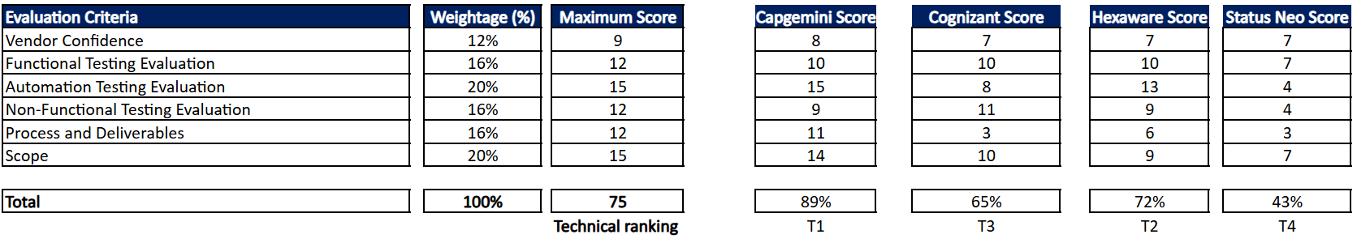  Although commercially ranked as L2, the Digital team recommends proceeding with Capgemini considering:  • Superior AI-enabled quality engineering maturity  • Platform-led automation-first delivery approach  • Faster transition and operational stabilization capability  • Reduced long-term operational dependency  • Stronger scalability and alignment with IndiGo’s Digital transformation roadmap  Cost and Efficiency Impact (high level Estimate)  The proposed engagement is expected to provide operational and transition efficiencies through:  • Early offboarding of approximately 30 resources by ~3 months  • Reduced dependency on extended parallel support models  • Faster stabilization of testing operations  • Earlier realization of automation and process standardization benefits  Estimated operational cost optimization during transition phase:  • Approx. INR 75 Lakhs per month  Hexaware was identified as the L1 vendor, Capgemini as L2 however Digital team would like to opt for Capgemini as the preferred vendor.  Cost Comparison attached here.  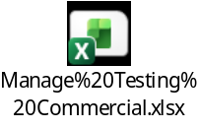
  Cost Comparison
   | Prices in INR (in Cr.)
   | Hexaware | Capgemini | Cognizant | Statusneo
  E2E Manage Testing for Web and Mobile | ₹5.00 | ₹6.00 | ₹26.76 | ₹46.10
  Tool/License cost | ₹0.00 | ₹0.56 | ₹0.00 | ₹0.45
  Total | ₹5.00 | ₹6.56 | ₹26.76 | ₹46.55
  Commercial Ratings | L1 | L2 | L3 | L4
  Technical Ratings | T2 | T1 | T3 | T4
What are the budgetary allocations | Cost for managed services vendor has been budgeted and will be funded through the Digital Resources budget allocation for FY 2026–27
Vendor Justification | Capgemini is recommended as the preferred strategic partner due to:  • Highest overall technical evaluation ranking (T1)  • Strong maturity in AI-enabled quality engineering capabilities  • Automation-first and platform-led delivery ecosystem  • Faster realization of operational efficiencies  • Reduced dependency on manual operational models  • Strong alignment with IndiGo’s future Digital and AI-led transformation initiatives
Exception on which approval is requested (Vendor Justification) | Although Capgemini is commercially ranked as L2, the Digital team recommends proceeding with Capgemini over the L1 bidder considering its stronger technical capability, superior automation maturity, accelerated transition approach, and long-term strategic alignment with IndiGo’s Digital transformation objectives.  The commercial variance against the L1 bidder is approximately 31%.
Prepared By | ------------------------- ------------------------  (Rinika Gautam) (Ashwani Sharma )
Reviewed By | ------------------ ------------------ ------------------  (Sunil Kumar) (Charu Verma) (Ravideep Singh)
Approved By | --------------------- -----------------  (Neetan Chopra) (Sanjay Jha)

